PowerShell Scripting Basics - Portfolio Version
Project Folder Creator Script

Project Summary
The script automates a repetitive setup task by asking the user for a date and project name, validating the date format, removing invalid filename characters, creating a main project folder, and adding standard subfolders.
- PowerShell user input with Read-Host
- Date validation using yyyy-MM-dd format
- Automatic main project folder creation
- Project name sanitization for Windows folder names
- Automatic creation of resources, data, and _archive subfolders
- Duplicate folder check with a clear message

Script Code
# Project Folder Creator Script
# This script creates a project folder and standard subfolders.
$dateInput = Read-Host "Enter a date (yyyy-MM-dd)"
$projectName = Read-Host "Enter a project name"
# Parent directory - change this path as needed
$parentDirectory = Join-Path -Path $HOME -ChildPath "Documents\PowerShell Scripts"
# Validate date format
if ($dateInput -match '^\d{4}-\d{2}-\d{2}$') {
# Remove invalid Windows filename characters from project name
$safeProjectName = $projectName -replace '[\\/:*?"<>|]', ''
# Combine date and project name
$folderName = "$dateInput - $safeProjectName"
$mainFolderPath = Join-Path -Path $parentDirectory -ChildPath $folderName
# Create parent directory if it does not exist
if (-not (Test-Path -Path $parentDirectory -PathType Container)) {
New-Item -Path $parentDirectory -ItemType Directory | Out-Null
}
# Create main folder and subfolders
if (-not (Test-Path -Path $mainFolderPath -PathType Container)) {
New-Item -Path $mainFolderPath -ItemType Directory | Out-Null
Write-Host "Folder '$folderName' created successfully at $mainFolderPath"
$subfolders = "resources", "data", "_archive"
foreach ($subfolder in $subfolders) {
$subfolderPath = Join-Path -Path $mainFolderPath -ChildPath $subfolder
New-Item -Path $subfolderPath -ItemType Directory | Out-Null
Write-Host "Subfolder '$subfolder' created successfully at $subfolderPath"
}
}
else {
Write-Host "Main folder '$folderName' already exists at $mainFolderPath"
}
}
else {
Write-Host "Invalid date format. Please use yyyy-MM-dd format."
}

Evidence of Completed Work - 1
Screenshot 1: The script runs and correctly handles initial folder creation and duplicate folder validation.

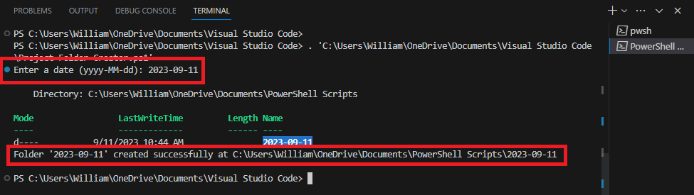
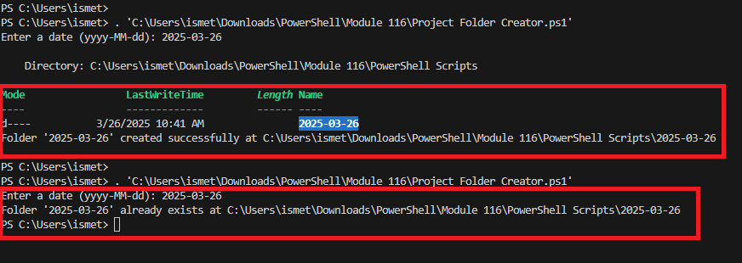

Evidence of Completed Work - 2
Screenshot 2: The script creates separate project folders when different project names are entered.
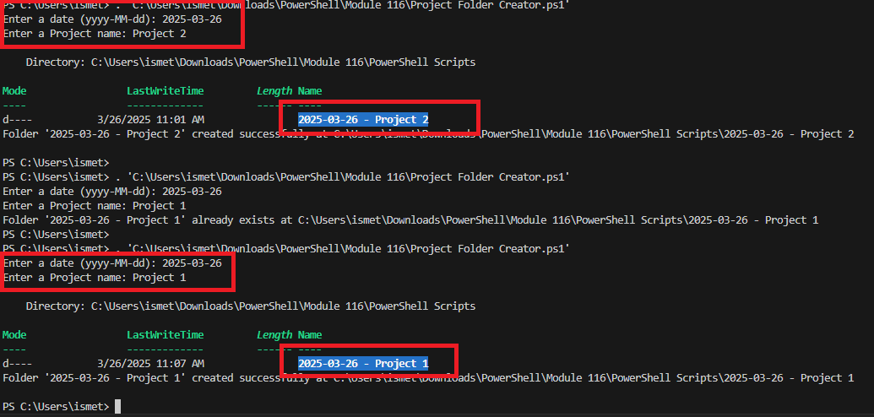

Evidence of Completed Work - 3
Screenshot 3: The script creates the standard subfolders inside the project folder.
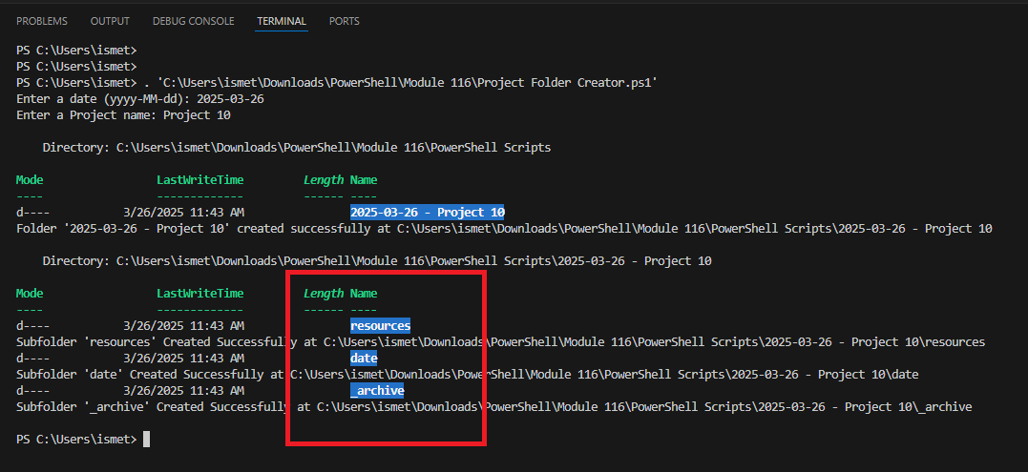

Evidence of Completed Work - 4
Screenshot 4: File Explorer verification showing the created project folder and subfolders.
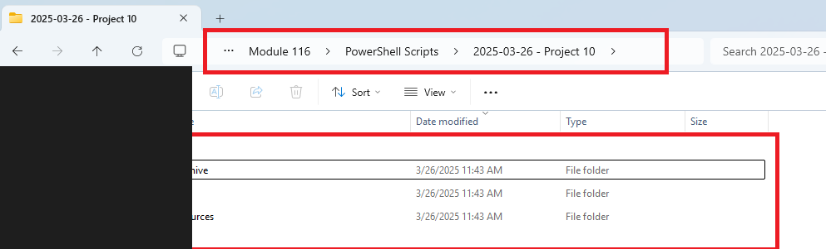

Learning Outcomes
This lab strengthened my understanding of PowerShell scripting, variables, conditional logic, loops, folder automation, input validation, and file-system organization.

